## 1. Color Scheme

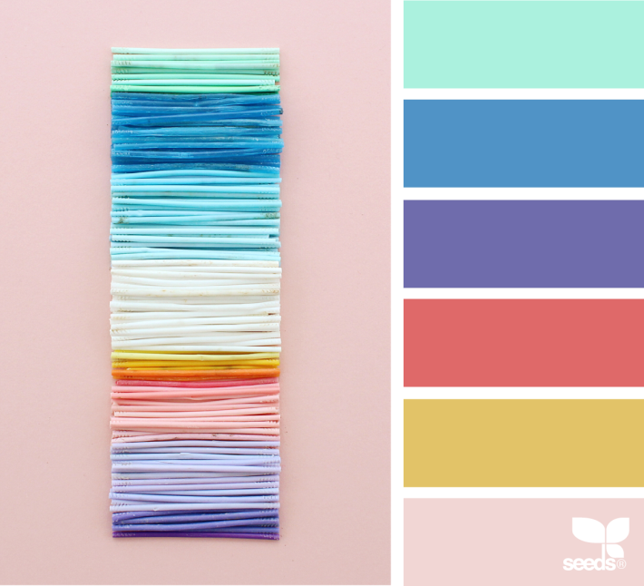

#AAF0DD

#4F92C6

#6E6BAB

#DE6868

#E1C267

#EFD5D3

Source: https://www.design-seeds.com/studio-hues/collage/color-collect-3/

## 2. Fonts

**Noto Sans**

To embed font: copy this code into the <head> of your HTML document.

<link href="https://fonts.googleapis.com/css?family=Noto+Sans:400,700" rel="stylesheet">

Specify in CSS

font-family: 'Noto Sans', sans-serif;